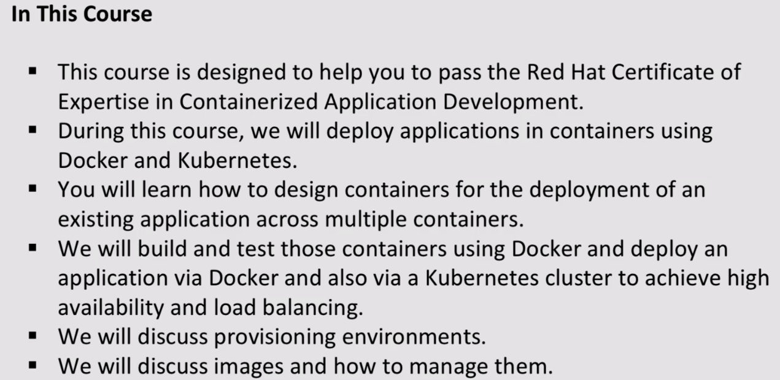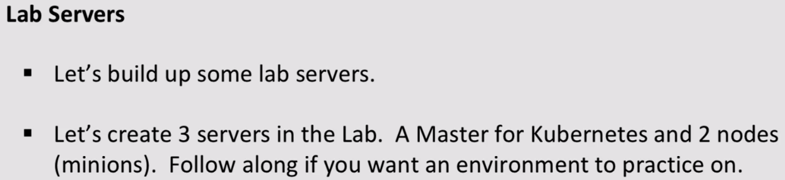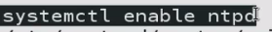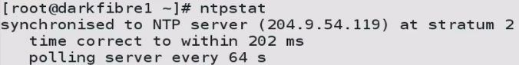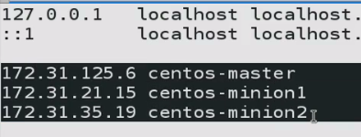

On mAster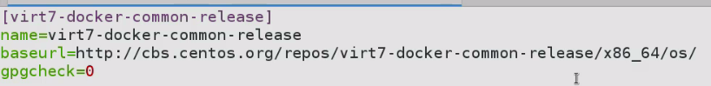

On minions/Nodes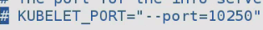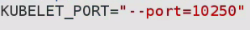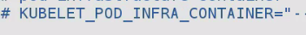

Do Same on node-2:

On master—Check

: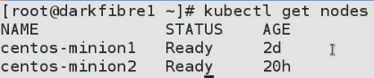Change hostname to remember:

On nodes--Check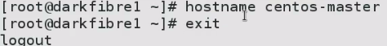

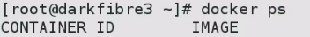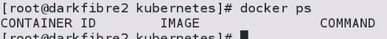 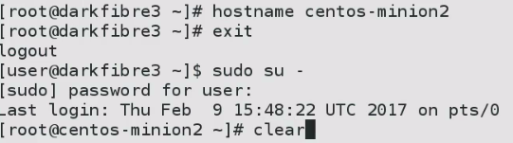

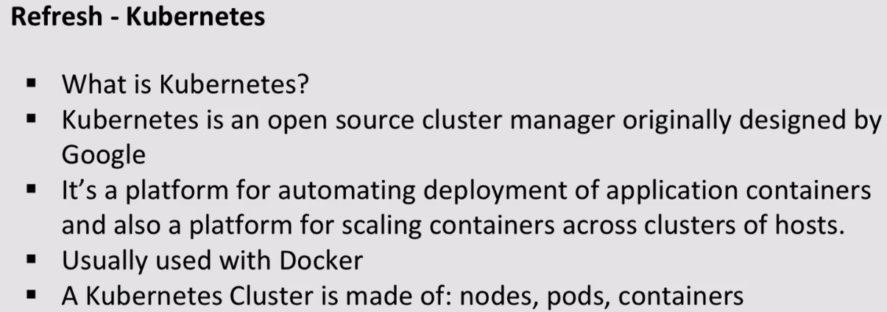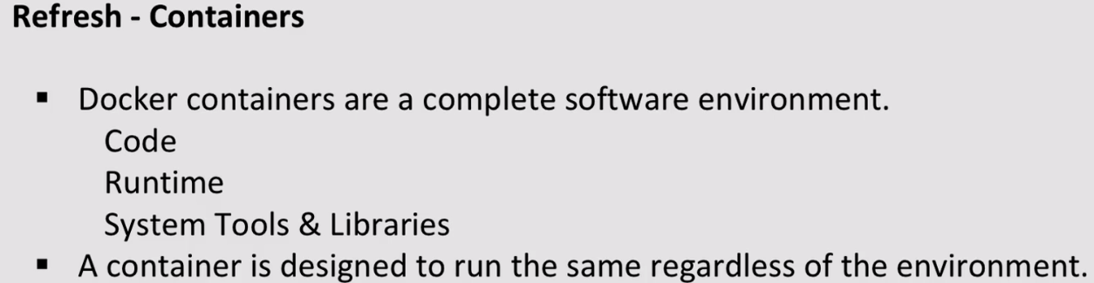

**110-907-2 - Provision a Database Server Using Container Technology**

****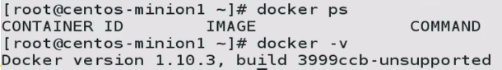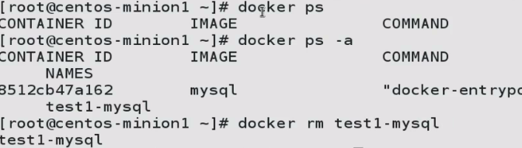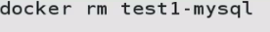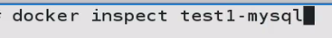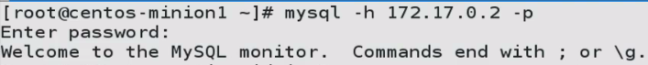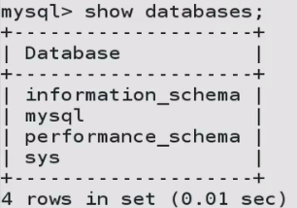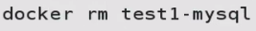

**IP is dynamic…Sol: Link containers**

110-908-1 - Link Containers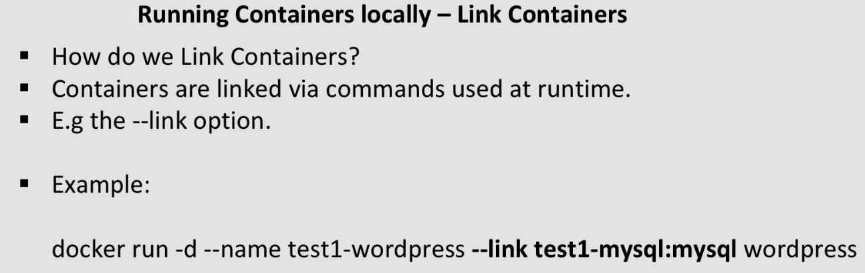

Test1-mysql🡪 instance we are going to instantiate.

Mysql-> name link will know by

Wordpress-> what we are going to instantiate..

With link: allows without using fixed IP inside your container for instance of wordpress container and database.We are able to use mysql, using link with test1-mysql

This will show on env. Of wordpress instance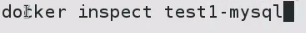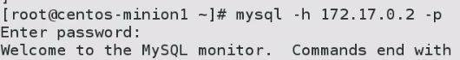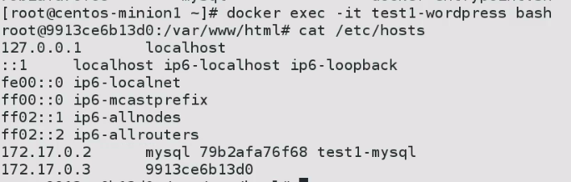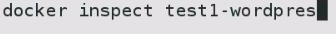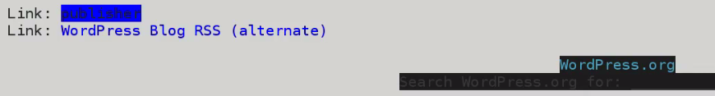

Linking a container with other: Created a database in mysql instance

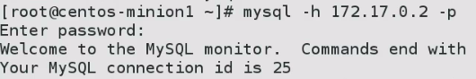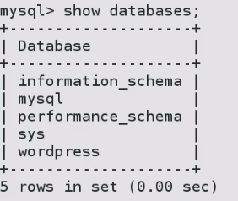wordpress DB is there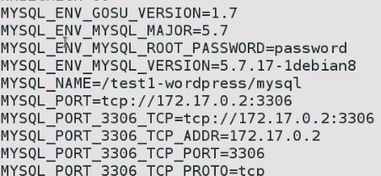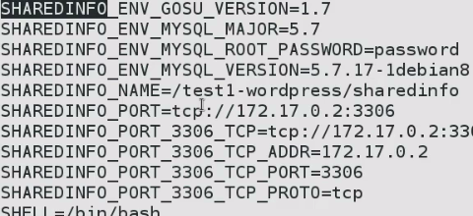

**110-908-2 - Get Container Logs**

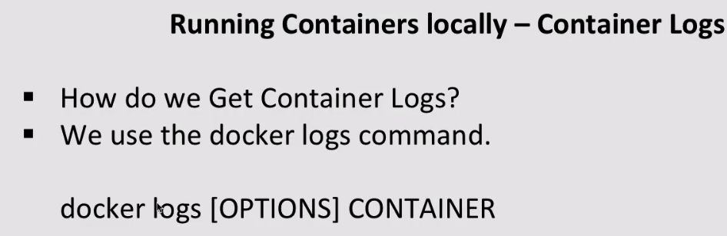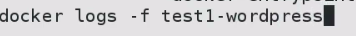

**TIP: PUT SOME SPACES AT BOTTOM, SO THAT WE CAN KNOW WHAT’s GOING ON..**

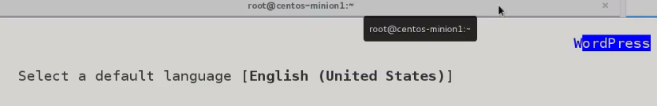

**We got wordpress up and here are logs for it..**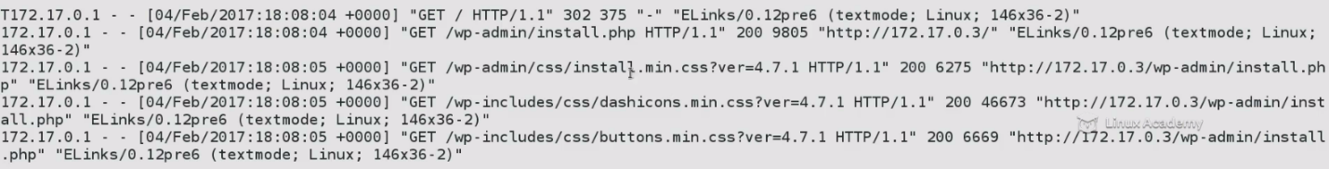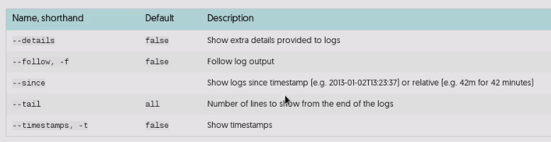

**TO GET LAST 5 LINES**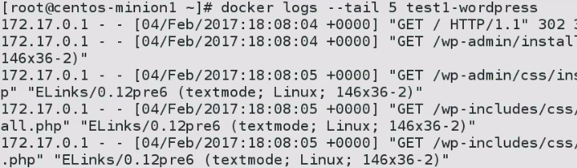

**110-908-3 - Listen to Docker Events on the Docker Host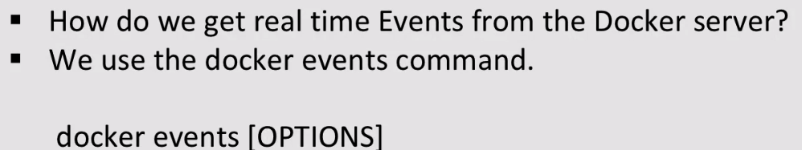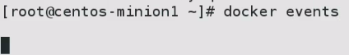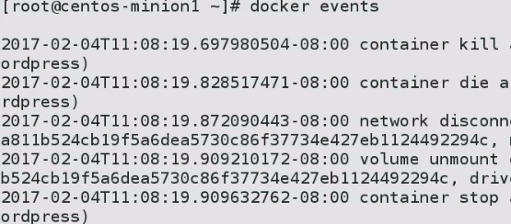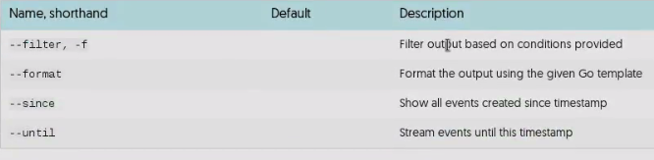110-908-4 - Use Docker Inspect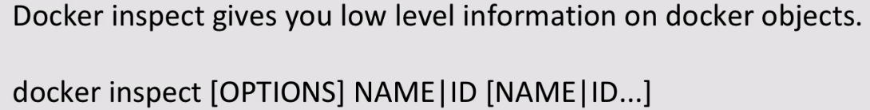110-908-5 - Share Data Between Containers Expose Containers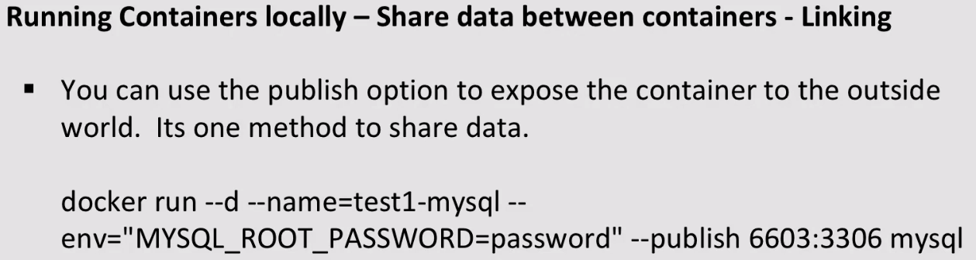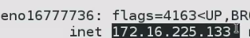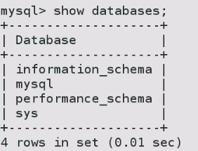p->password**

**P->Port**

**110-908-6 - Persistent Storage for Containers**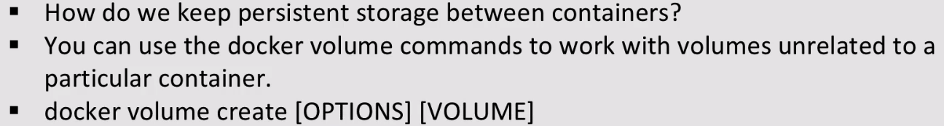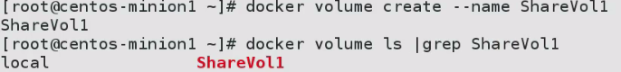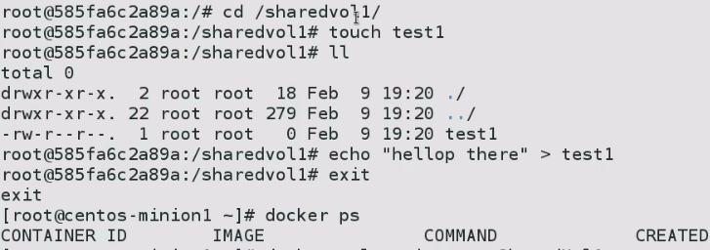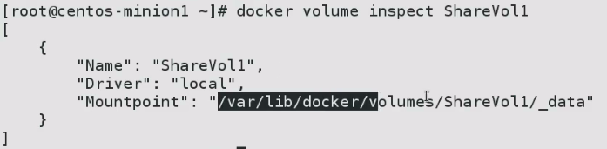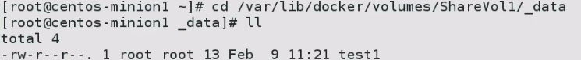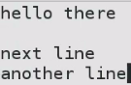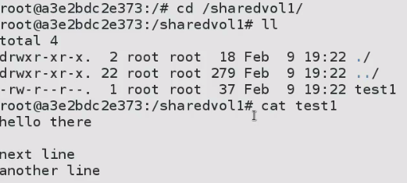

**Note: Now, create a new file test2**

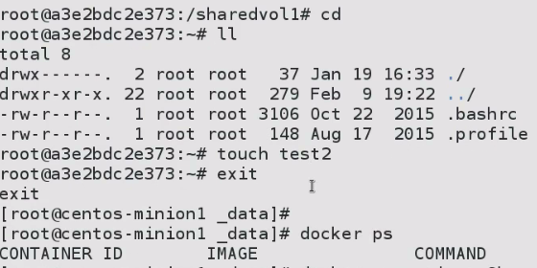

**Instantiate a new container**

**No test2 file…But shared volume exists**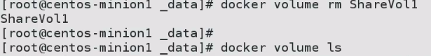

**3.) We can also add volume from other container:**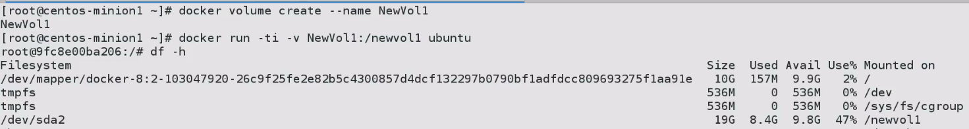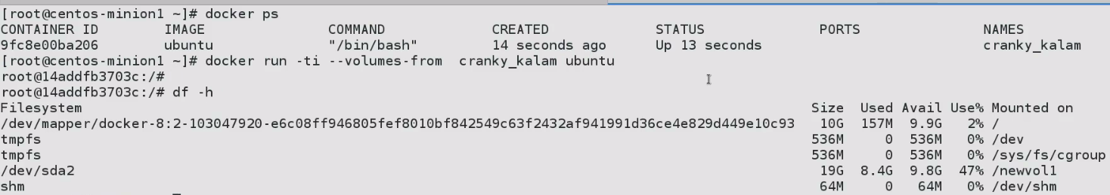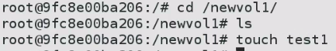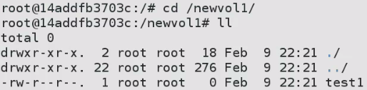

**Volumes are isolated FS.They can be used to store states between containers.**

**If we have playbook on volume, and blow it away.. We can have 2nd container and begin where it left off.**

**110-908-7 - Host and Container Basic Security Best Practices…**

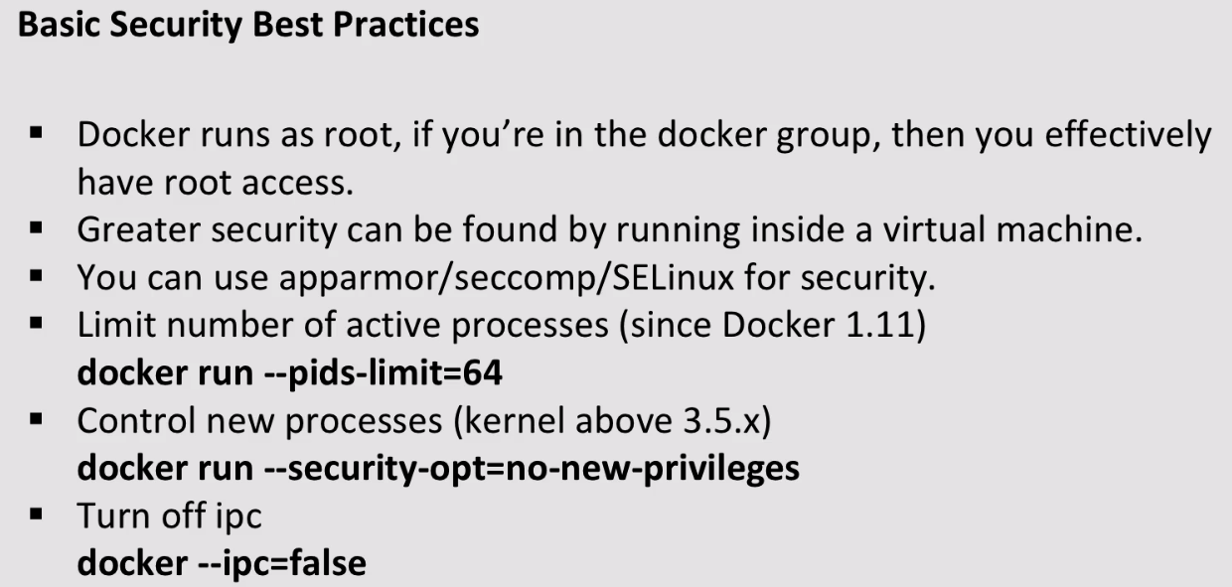

**2. This limits amount of access docker container will have to underlying host.**

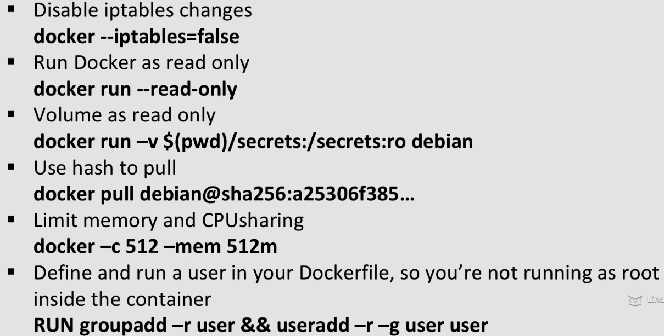

**If we link container, doesn’t itself make/add necessary changes to firewall**

**110-908-8 - Orchestrating Containers Using Kubernetes**

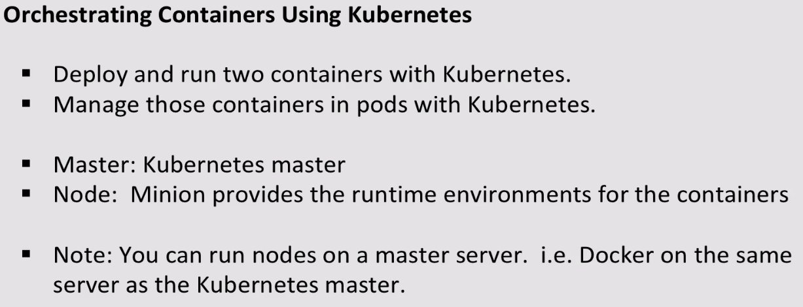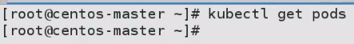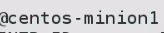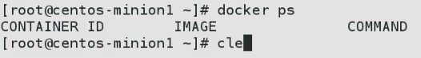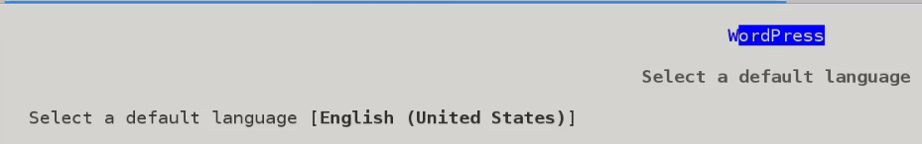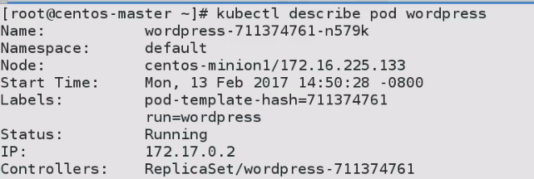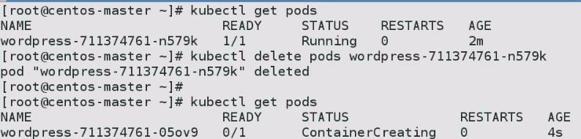

**Ready Changed from 1/1 to 0/1..**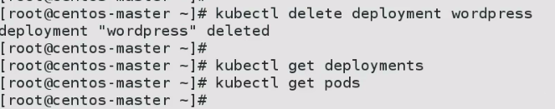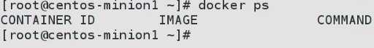

**Using YAML FILE:**

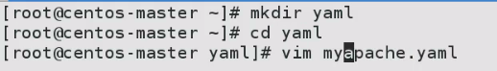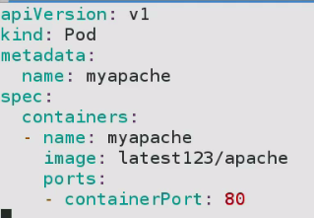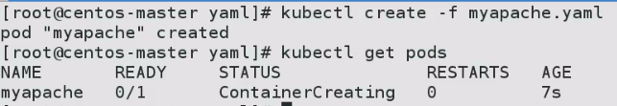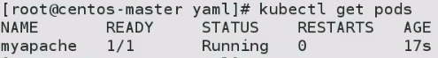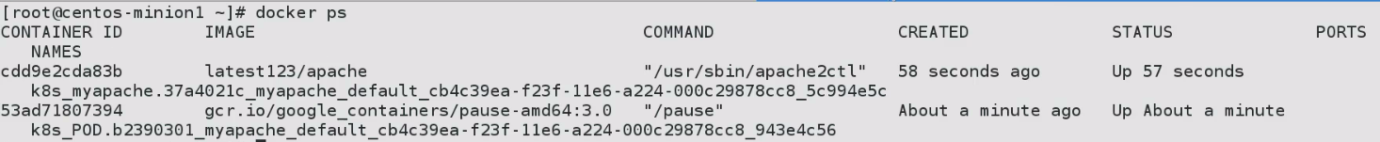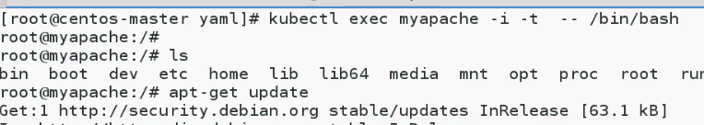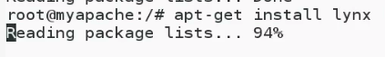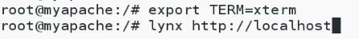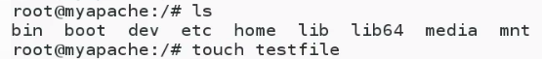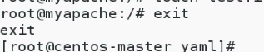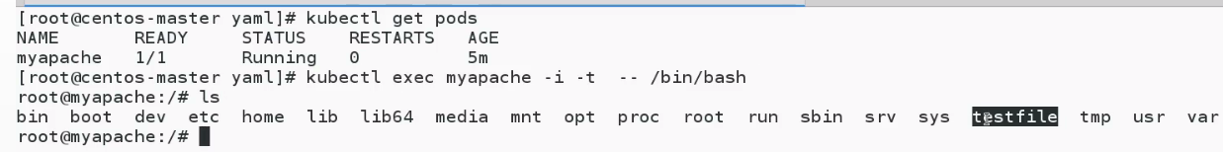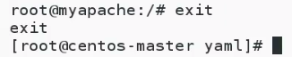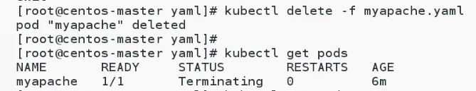

**110-910-1 - What are Image Registries?**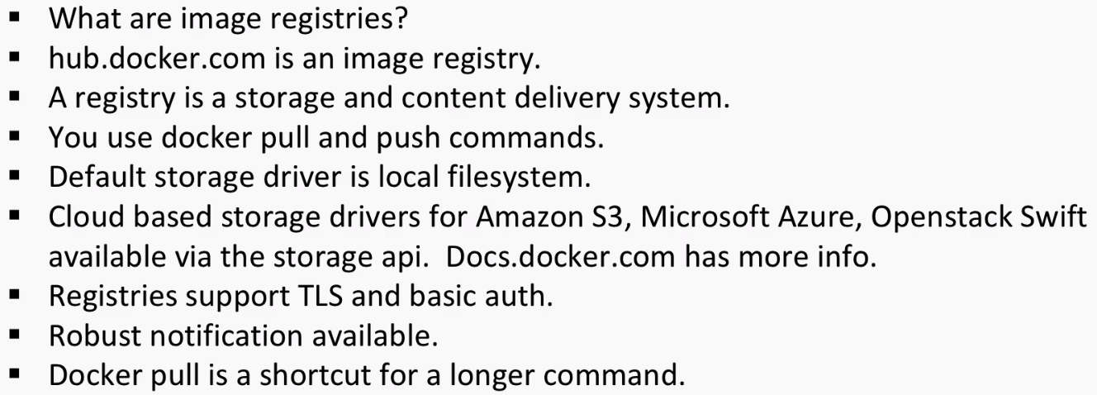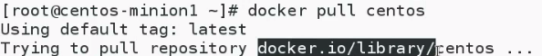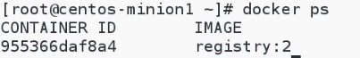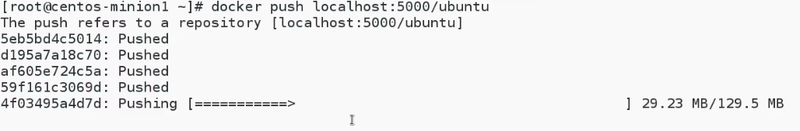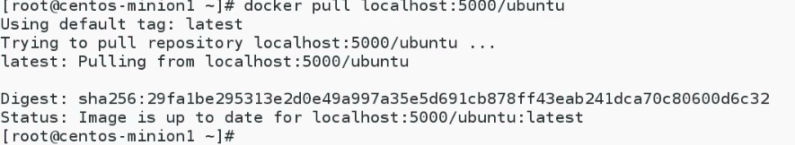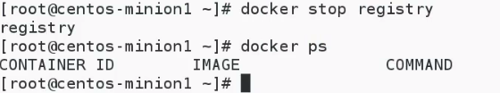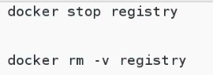

* + 1. **- Image Design Best Practises**

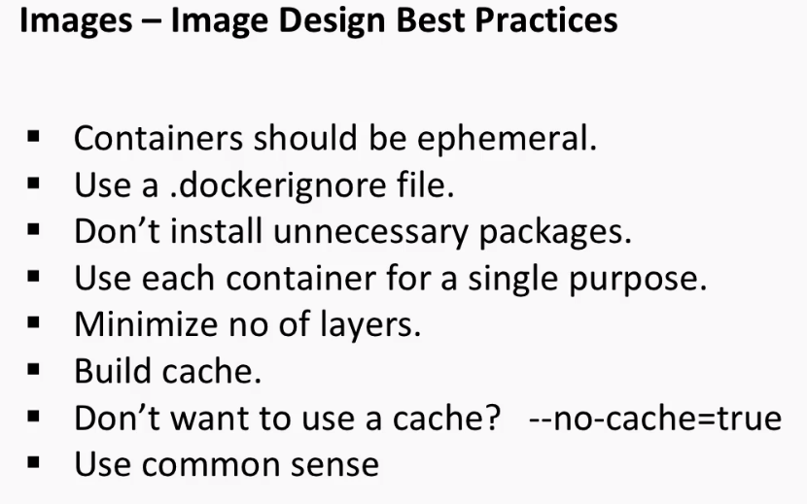

1. **Containers should be able to stop and destroy them.**

**Any data that persists should be stored in DB.**

1. **Excluded files**

**110-910-3 - Working with Images**

1. 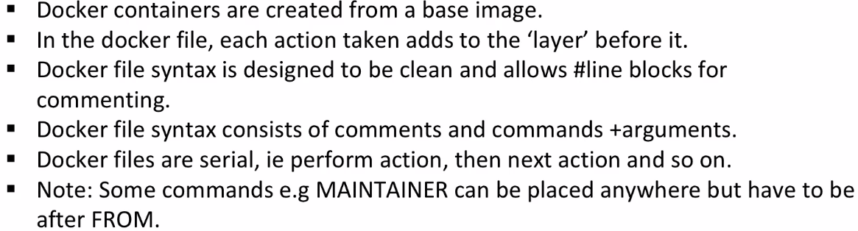

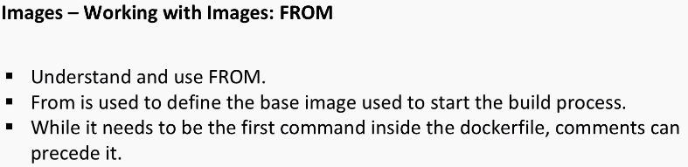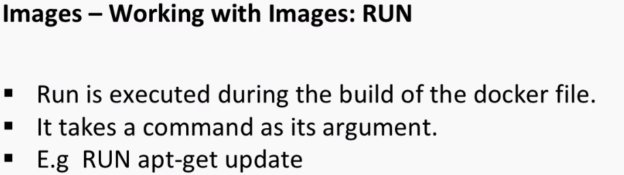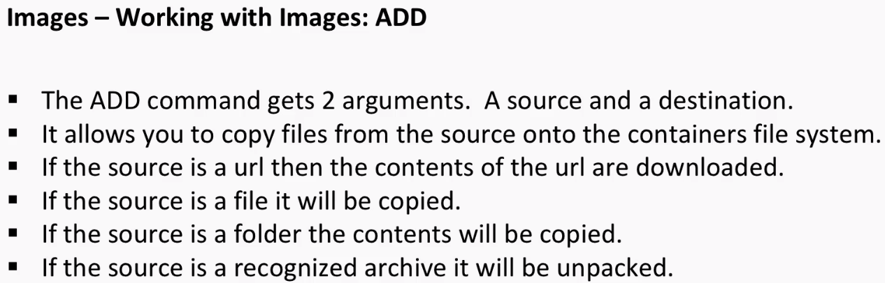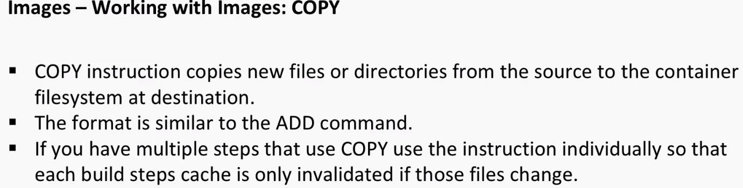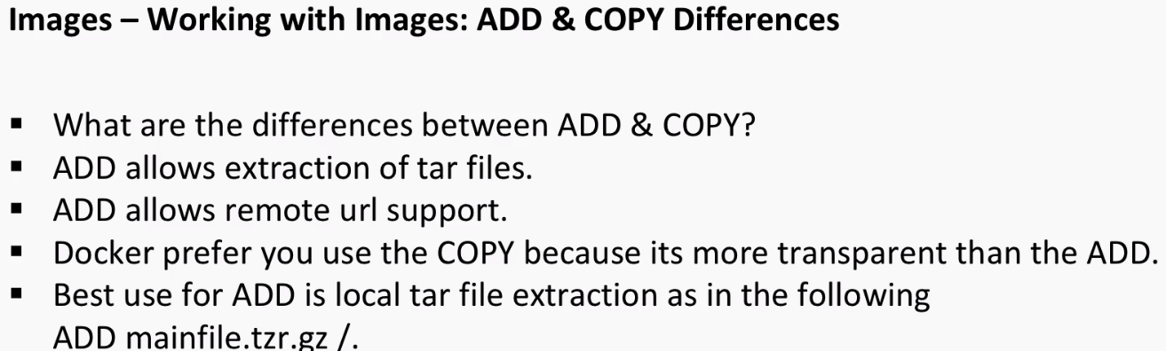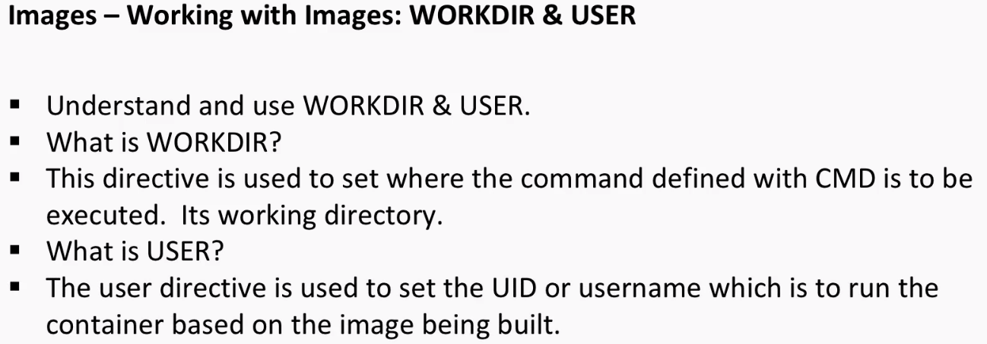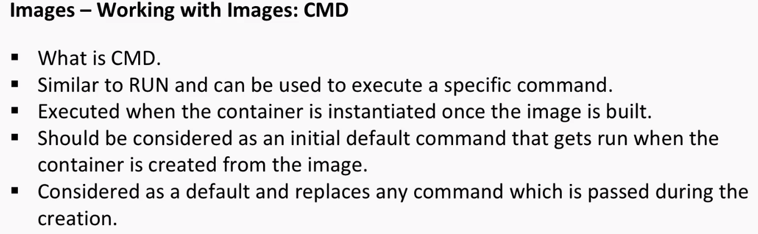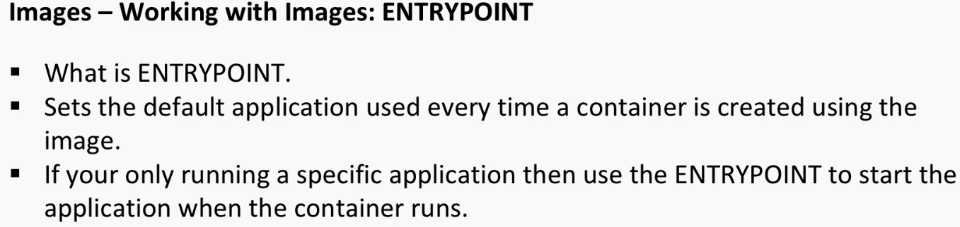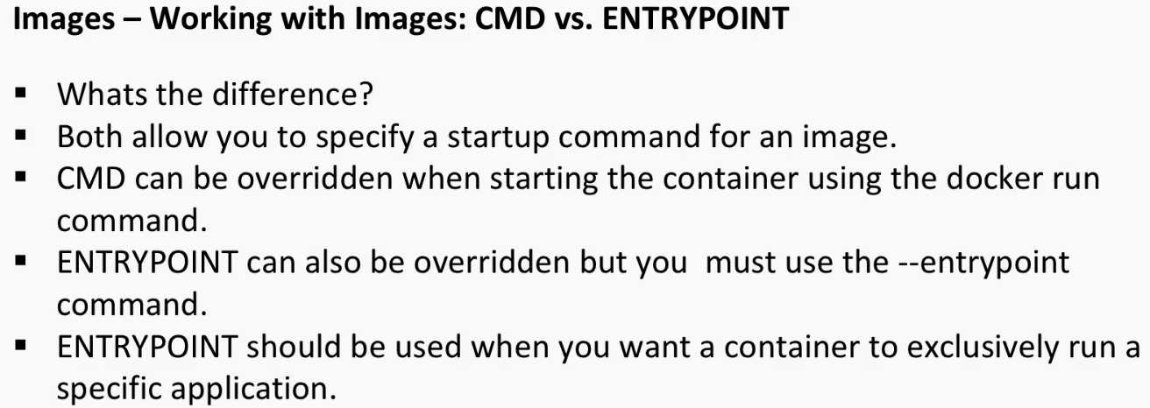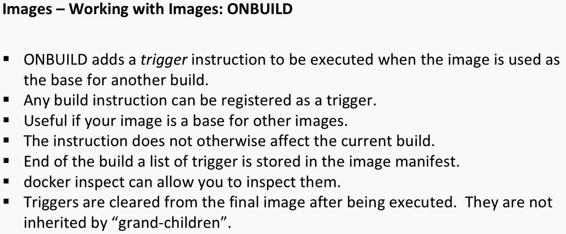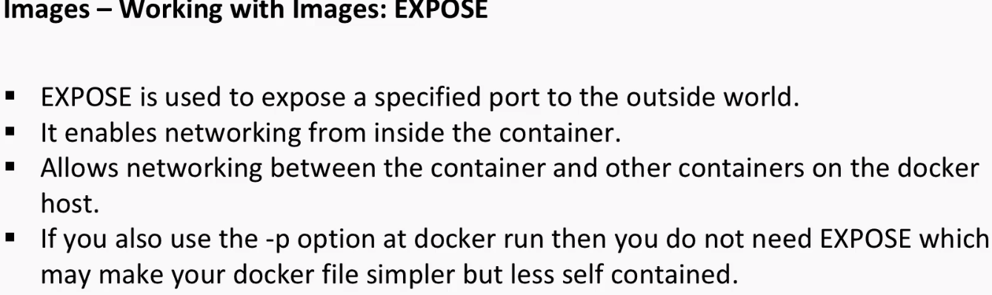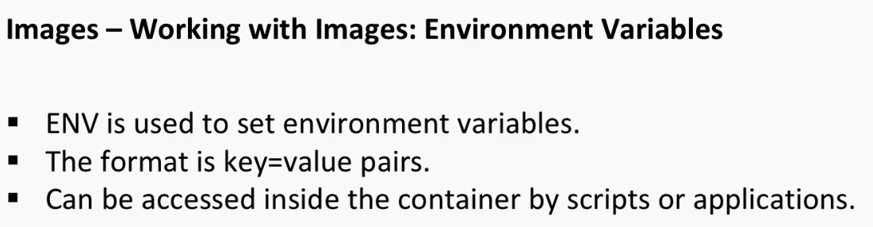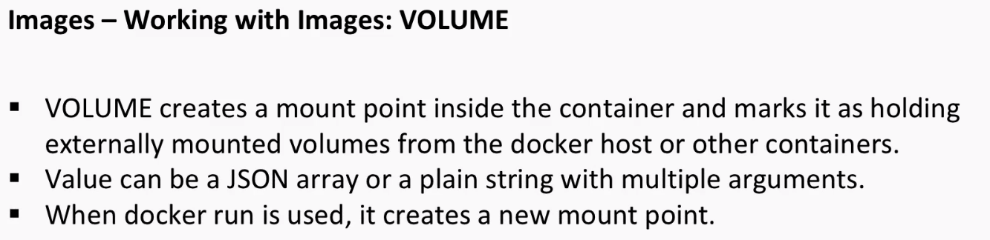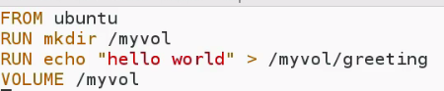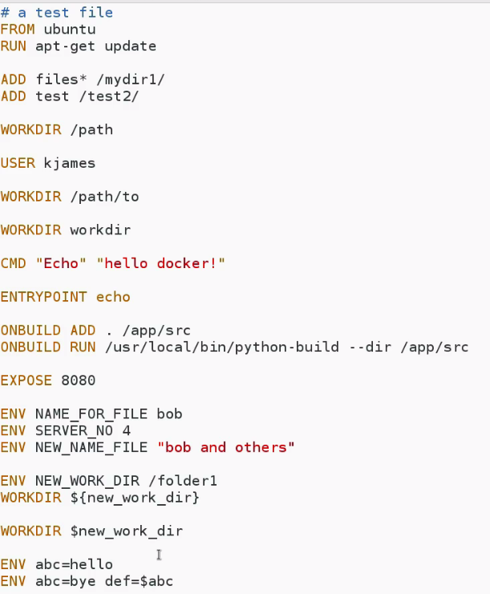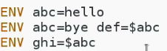

* + 1. **- Create Custom Images**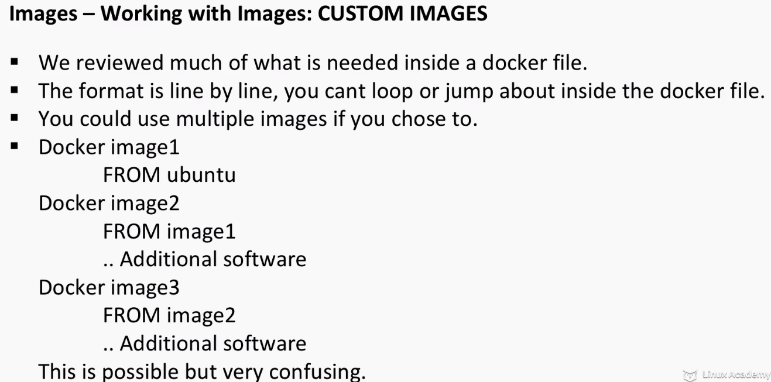

**In some cases, we don’t need a custome image. We can pull straight from docker hub.**

**If we are making changes, and want to take control of image, and adjoin software then we have to go for Custom image..**

* + 1. **- Design and Code a dockerfile to Build a Custom Container Image**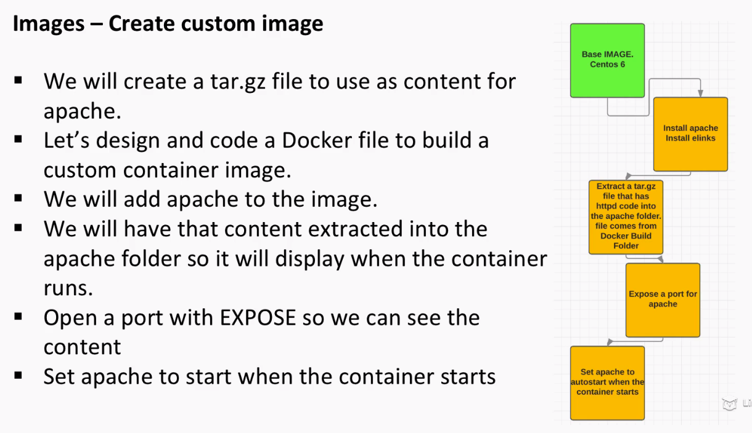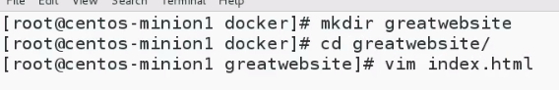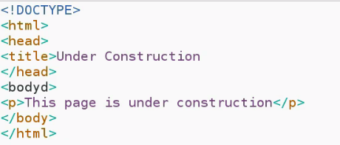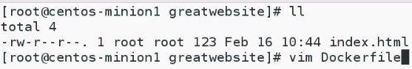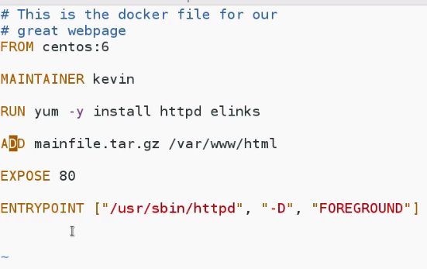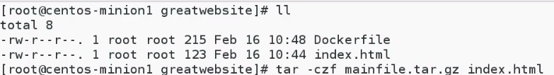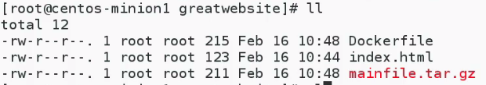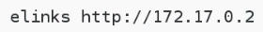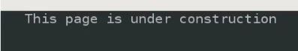
    2. **- Manage the Lifecycle of an Image from Creation to Deletion**
    3. 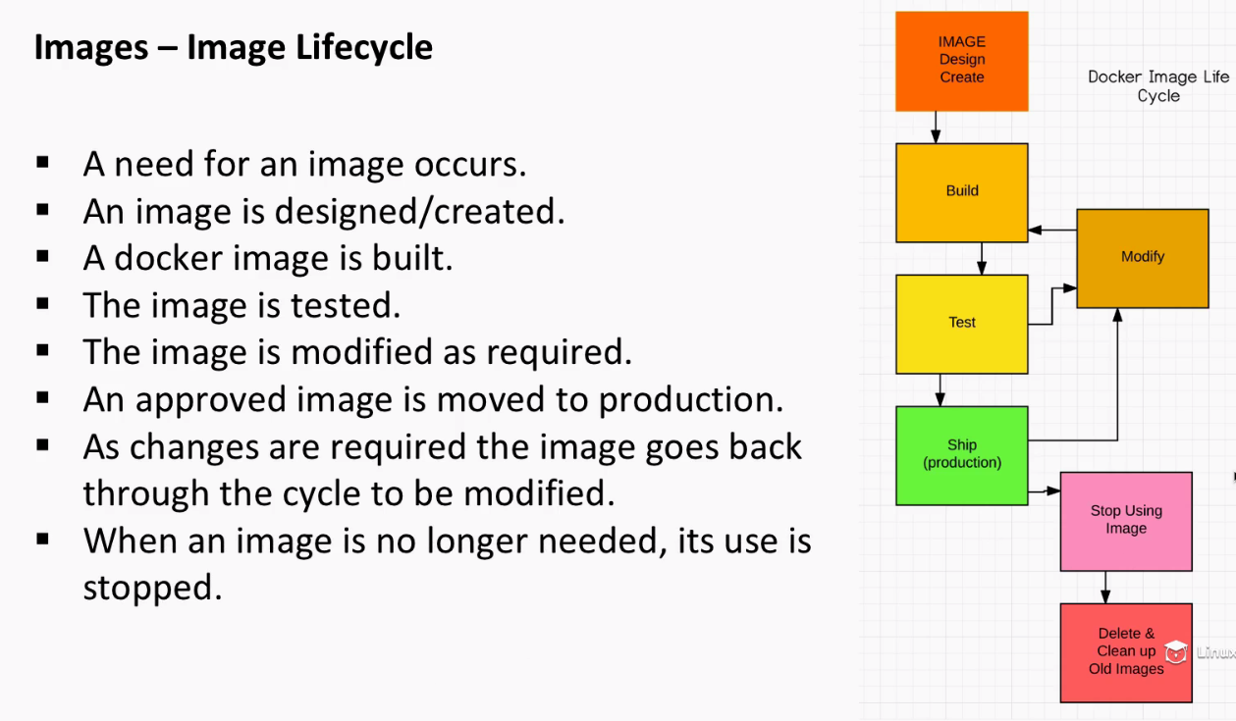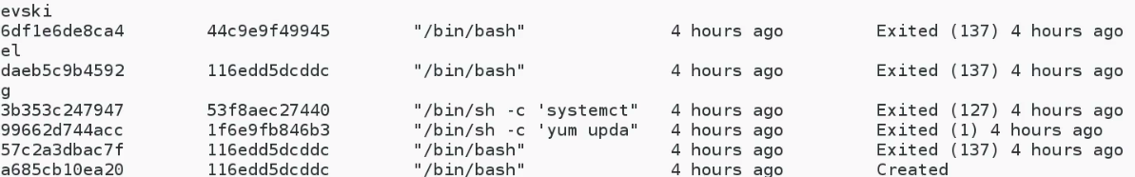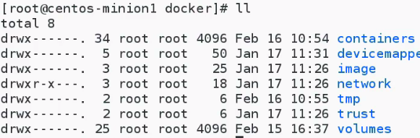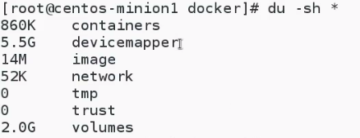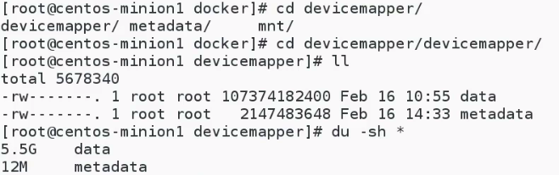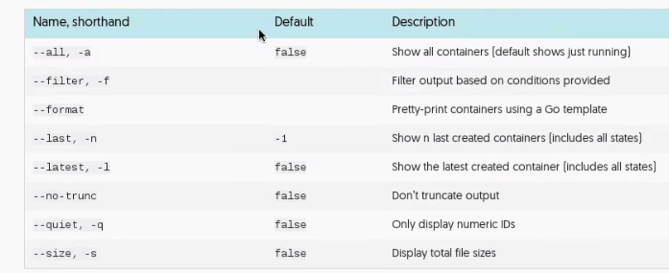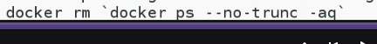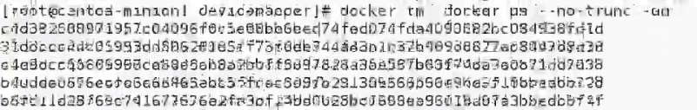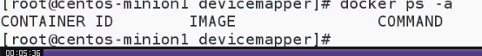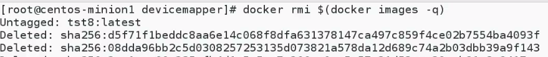

**110-911-1 - Design Container Images for Application Deployment**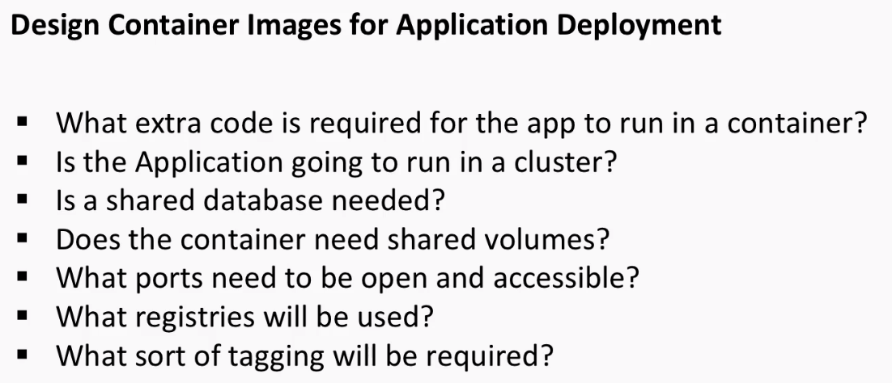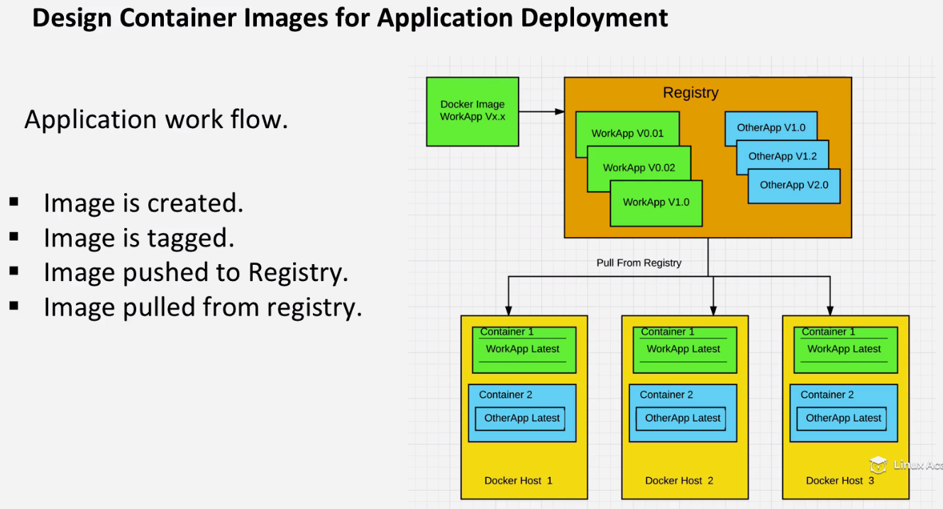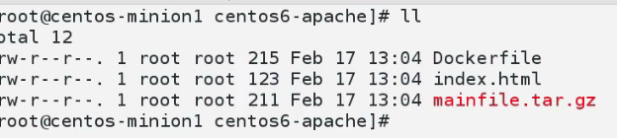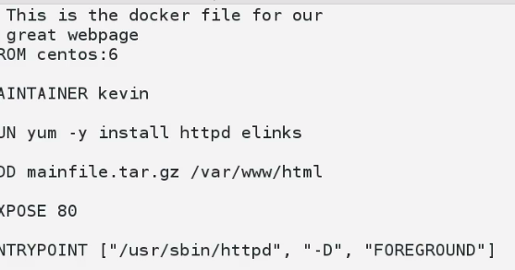

**We can give multiple tags.**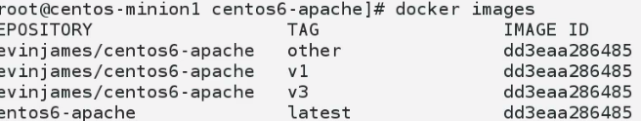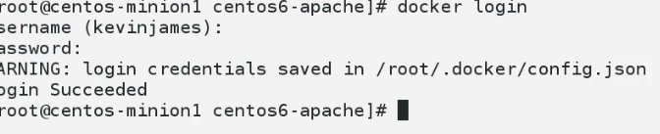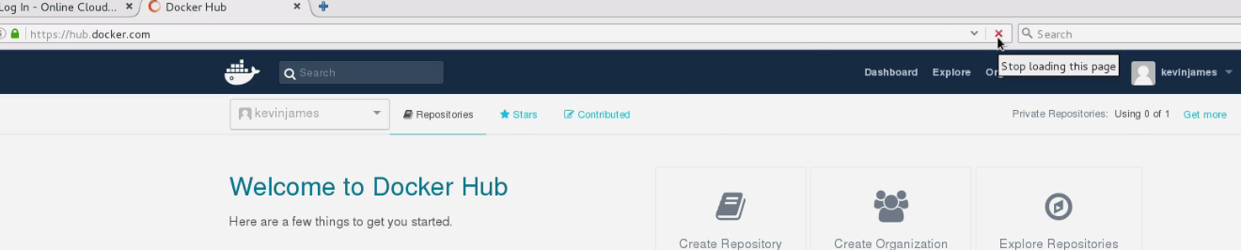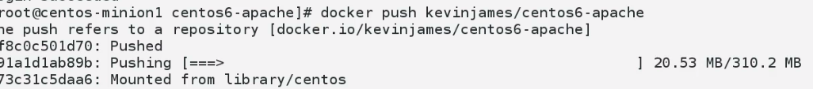

**All images will be pushed, if tag is not mentioned**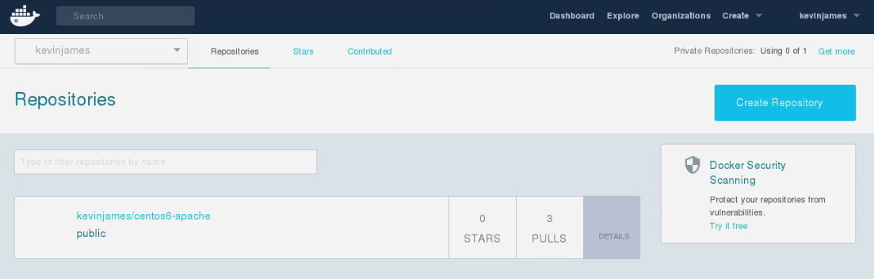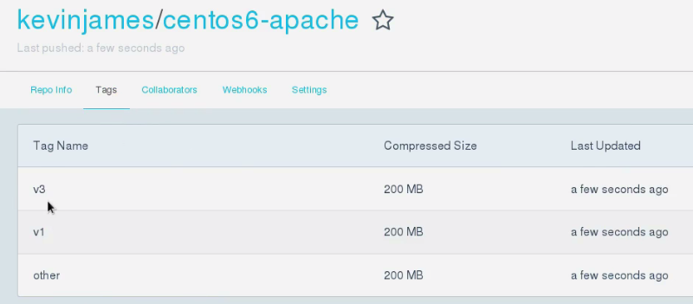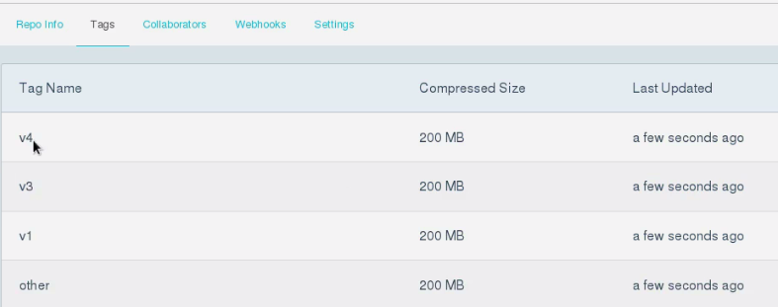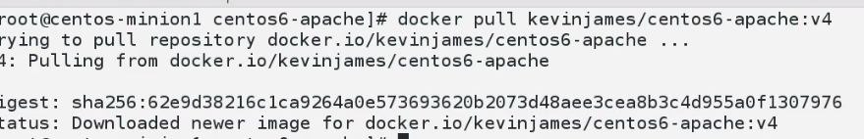

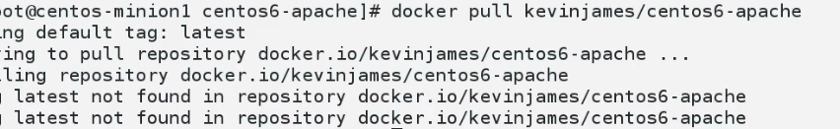

**NO LATEST IS THERE….**

**If we build image, without putting tag..It will be latest**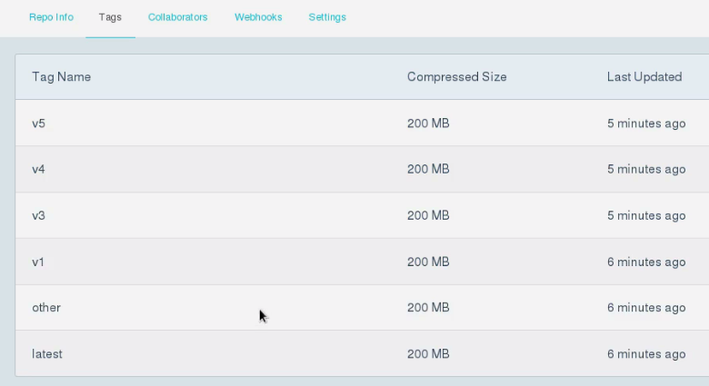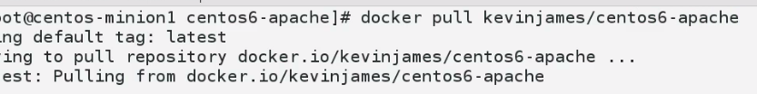

**110-911-2 - Custom Images for Multiple Container Application Deployment**

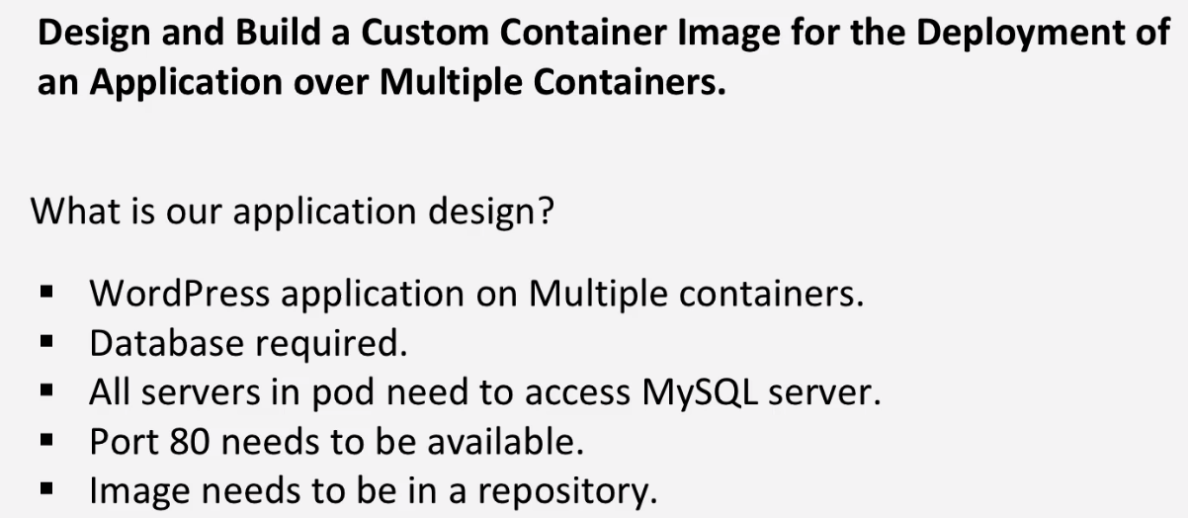

**110-911-3 - Understand Private Registry Security**

**We are going to create resgistry, and going to create another registry that is secured:**

**- Creating TLS certificate, and adding to repository.**

**- Diff. is communication is encrypted. We are going to use TLS and secure socket layers for this. Both refers to SSL. They provide security over computer network.**

**TLS is used to primarily to provide privacy and integrity b/w 2 computers/comm. Devices.**

**Connection is private and identity of parties communicating are authenticated. They have authority to talk to each other…Also they have integrity check.. Message transmitted have integrity check..**